Let’s Read and Color



Red

Blue

Yellow

Green

A

B

D

C

1. Belajar Mengenal Warna
2. Mengetahui kosakata dalam bahasa inggris untuk warna
3. Menceritakan mengenai warna

What is not belongs here?

1)



Violin



Piano



drum

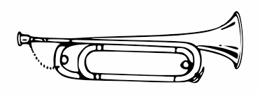

Trumpet

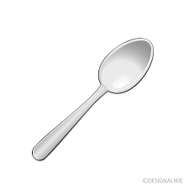

Spoon

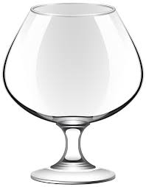

Glass

)

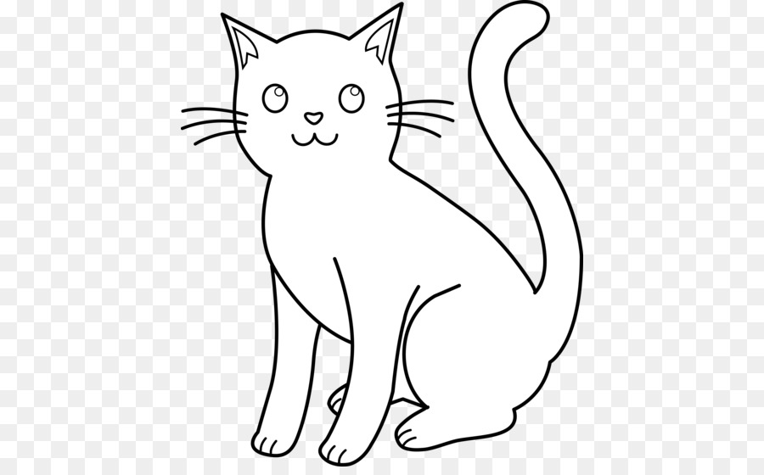 

 

 

 









A B C









D E

Make a story with the box?

1)

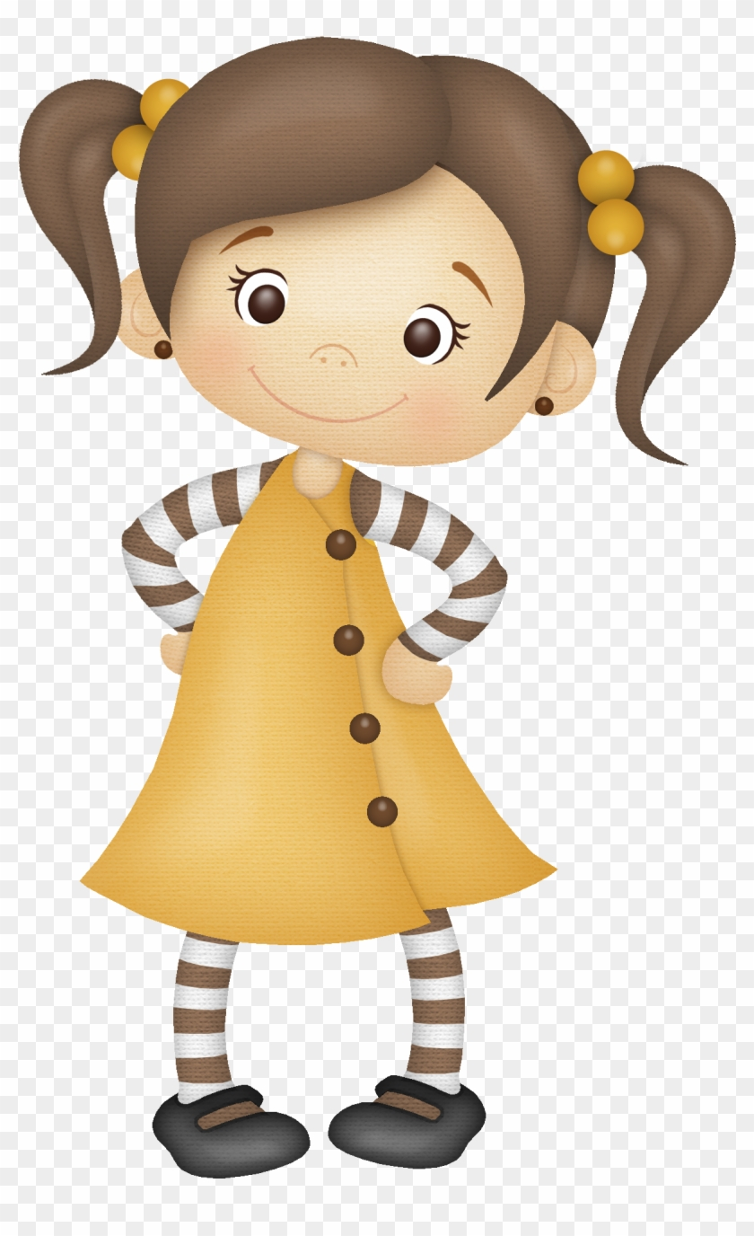

A Girl

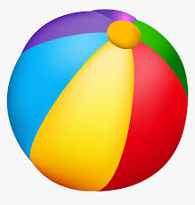

The Ball

Threw

2)

Caught



The Ball

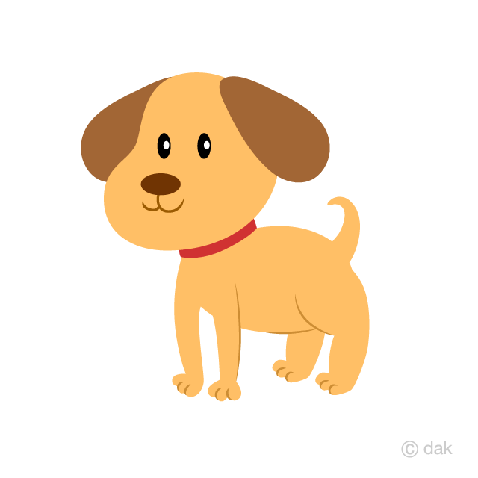

A Puppy

3)



Ate a Snack

**And**



The Puppy



The Girl